DEPLOY03_TEST

Author: Toshaya Watson

Table of Contents

AWS EC2 Instance 2

GitHub 2

Setup Jenkins 2

Possible Errors 4

Excepted outcome 4

New Functionality Test 4

# AWS EC2 Instance

This assumes that the user has a pre-existing EC2 Instance.

1. Select the instance you wish to run.
2. Select the dropdown ‘Instance state’.
   1. Select Start instance
3. Instance state should state “Running”.
   1. If this is not reflected after 3 mins, refresh the webpage.
4. Select the ‘Instance ID’.
   1. Stroll down to the middle of the page and select ‘Networking’
   2. Go to ‘Public IPv4 address’
   3. Copy the address

# GitHub

1. Fork (<https://github.com/kura-labs-org/DEPLOY03_TEST>)
2. Open ‘Deployment 3.pdf’ and follow the instructions

# Setup Jenkins

1. Paste the Public IP address in the search engine
   1. Add :8080 to log into the correct port.
2. Create a new pipeline
   1. Under Dashboard
      1. Select New Item
         1. Enter an item name
         2. Select ‘Freestyle project’
         3. Select ‘OK’
      2. Go to ‘Source Code Management’ tab
         1. Select ‘Git’
            1. Enter the ‘Repository URL and Credentials
            2. Under Branches to build replace master with main.

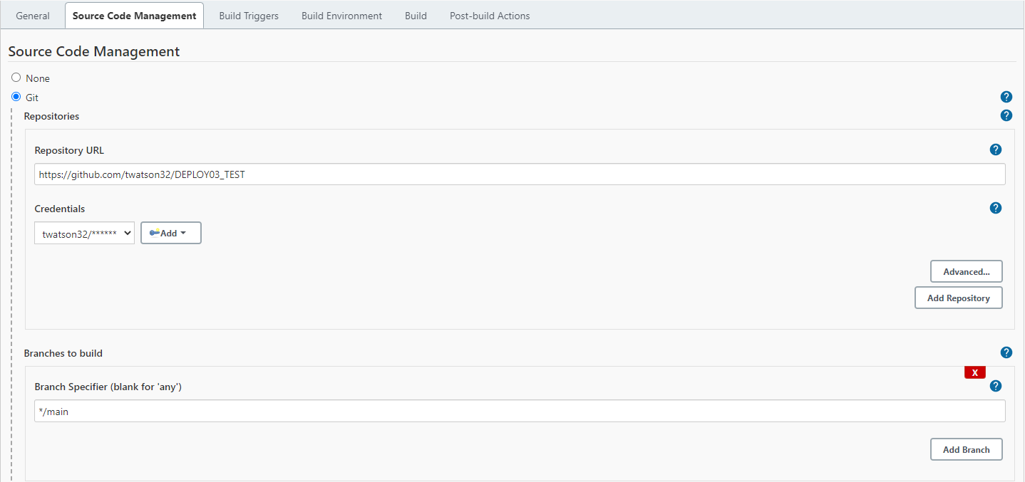

* + 1. Under the ‘Build’ tab
       1. Go to the dropdown menu and select ‘Execute shell’
          1. Enter the following command

#!/bin/bash

python3 -m venv test3

source test3/bin/activate

pip install pip --upgrade

pip install pytest

py.test --verbose --junit-xml test-reports/results.xml sources/test_calc.py

* + 1. Go to ‘Post-build Actions’
       1. Under ‘Test report XMLs enter “test-reports/results.xml”

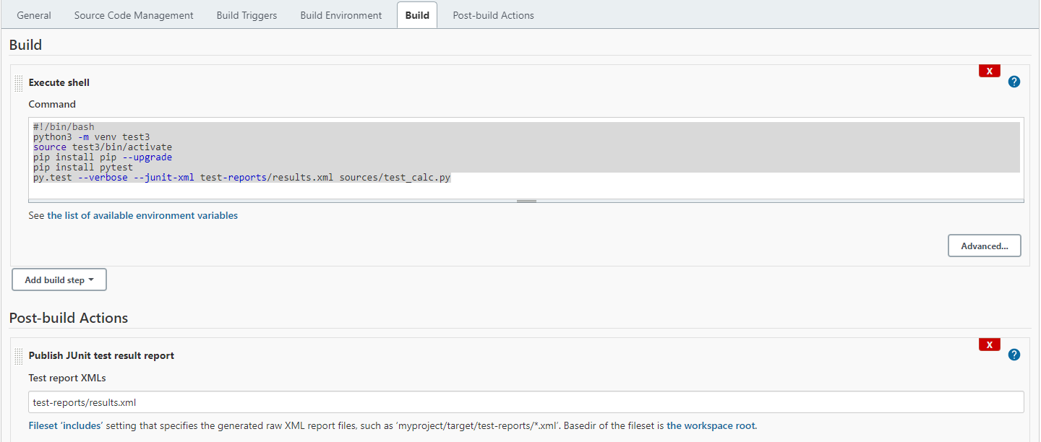

* + 1. Select ‘Apply’
    2. Select ‘Save’

## Possible Errors

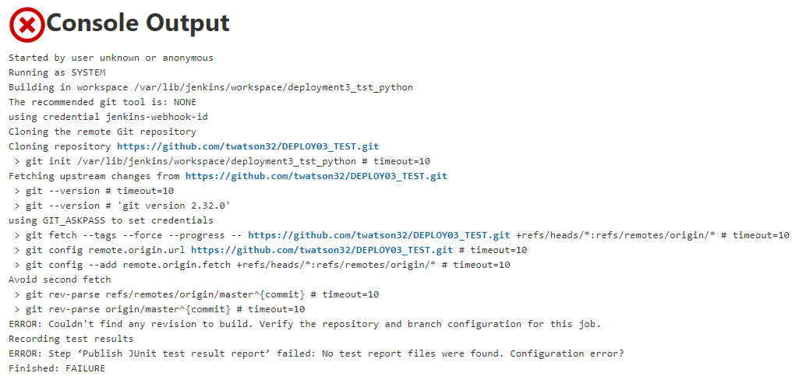

The following error will be observed if you did not replace master with main

Go to Configure under your project to update the name

## Excepted outcome

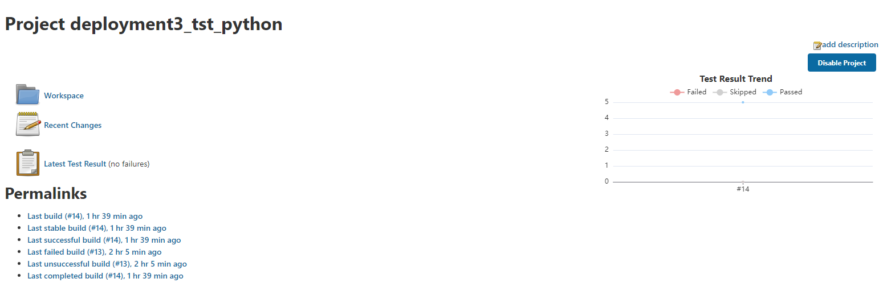

# New Functionality Test

1. Reopen Git Hub
2. Under ‘Deploy03_test’ in the newly forked repository open the sources folder.
3. Select ‘calc.py’ code
   1. Select edit
   2. Add a new function to multiply 2 numbers to the code

# The 'multi2' function itself

def multi2(arg1, arg2):

# Convert 'arg1' and 'arg2' to their appropriate types

arg1conv = conv(arg1)

arg2conv = conv(arg2)

# If either 'arg1' or 'arg2' is a floats, ensure they're both floats.

if isinstance(arg1conv, float) or isinstance(arg2conv, float):

arg1conv = float(arg1conv)

arg2conv = float(arg2conv)

return arg1conv * arg2conv

* 1. Commit the changes to the main branch

1. Return to the ‘sources’ folder
2. Select ‘add2vals.py code
   1. Select edit
   2. Print the output for the function you just created by inserting the following line:
      1. print("The result is " + float(calc.multi2(float(sys.argv[1]), float(sys.argv[2]))))
   3. Commit the changes to the main branch
3. Return to the ‘sources’ folder
4. Select ‘test_calc.py’ code
   1. Select edit
   2. Insert the following lines

def test_multi_integers(self):

"""

Test that the addition of two integers returns the correct total

"""

result = calc.add2(1, 2)

self.assertEqual(result, 3)

* + 1. This should result in an error.

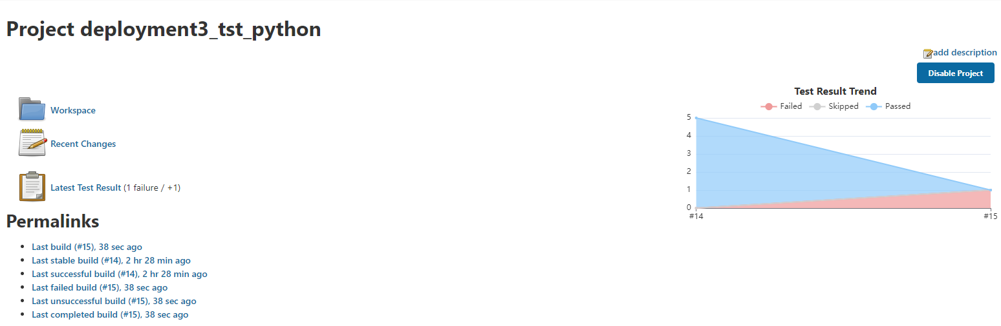

1. Review the error

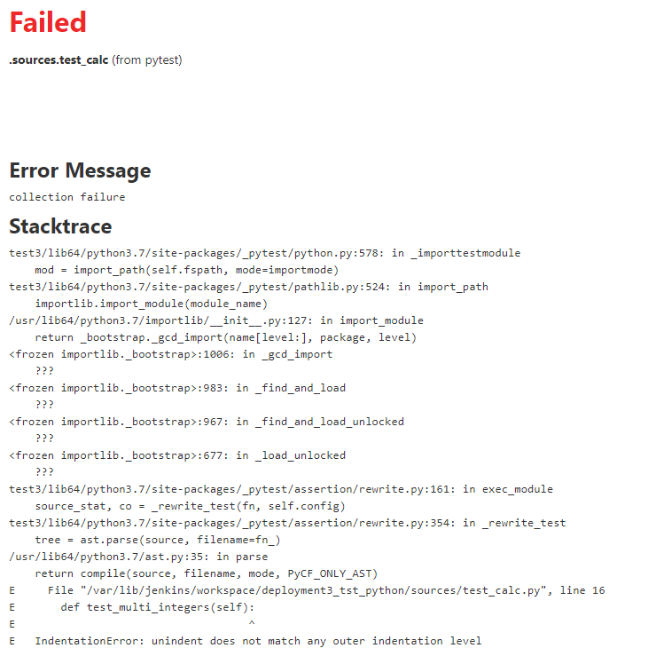

1. Return to the test_calc.py code
   1. Select edit
   2. Update the test_multi_intergers(self)

def test_multi_integers(self):

"""

Test that the addition of two integers returns the correct total

"""

result = calc.multi2(4, 2)

self.assertEqual(result, 8)

1. Return to Jenkins and run the build.
2. Build should run successfully.

